**DAILY ONLINE ACTIVITIES SUMMARY**

|  |  |  |  |  |  |  |  |  |
| --- | --- | --- | --- | --- | --- | --- | --- | --- |
| **Date:** | **16/06/2020** | | | | | **Name:** | **POOJA D S** | |
| **Sem & Sec** | **4th SEM 'B' Section** | | | | | **USN:** | **4AL18CS056** | |
| **Online Test Summary** | | | | | | | | |
| **Subject** | | **COMPLEX ANALYSIS,PROBABILITY AND STATISTICAL**  **METHODS** | | | | | | |
| **Max. Marks** | | **30** | | **Score** | | | **24** | |
| **Certification Course Summary** | | | | | | | | |
| **Course** | **Blockchain Basic** | | | | | | | |
| **Certificate Provider** | | | **Great Learning Academy** | | **Duration** | | | **2.5 hour** |
| **Coding Challenges** | | | | | | | | |
| **Problem Statement:** A user will input two strings, and we find if one of the strings is a sub sequence of the other. Program prints “yes” if either the first string is a sub sequence of the second string or the second string is a sub sequence of the first string. Assume that, the length of the first string is smaller than or equal to the length of the second string. Assume that, the length of the first string is smaller than or equal to the length of the second string. | | | | | | | | |
| **Status: completed** | | | | | | | | |
| **Uploaded the report in Github** | | | | | **yes** | | | |
| **If yes Repository name** | | | | | <https://github.com/dspooja/Java-coding/blob/master/june%2016th%20BST.py> | | | |
| **Uploaded the report in slack** | | | | | **yes** | | | |

Online Test Details: (Attach the snapshot and briefly write the report for the same)

Certification Course Details: (Attach the snapshot and briefly write the report for the same)

Coding Challenges Details: (Attach the snapshot and briefly write the report for the same)

ONLINE TEST DETAILS:

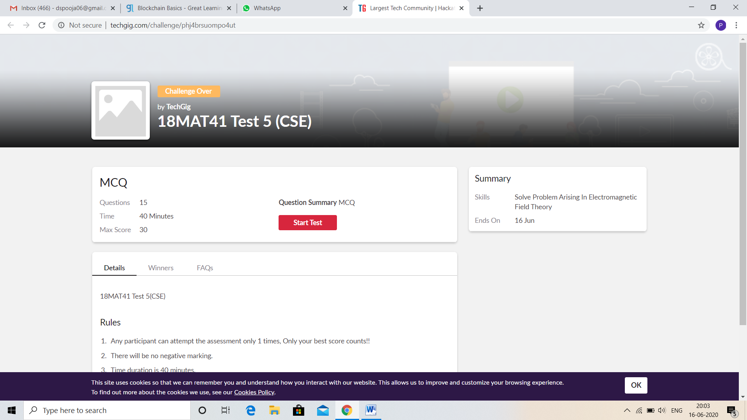

CERTIFICATION COURSE DETAILS:

* My Certification Course is Blockchain Basic.
* **The concepts covered in** Blockchain Basic **are:**
* Database system
* What is Blockchain
* Database Vs Blockchain
* Role of Intermediaries

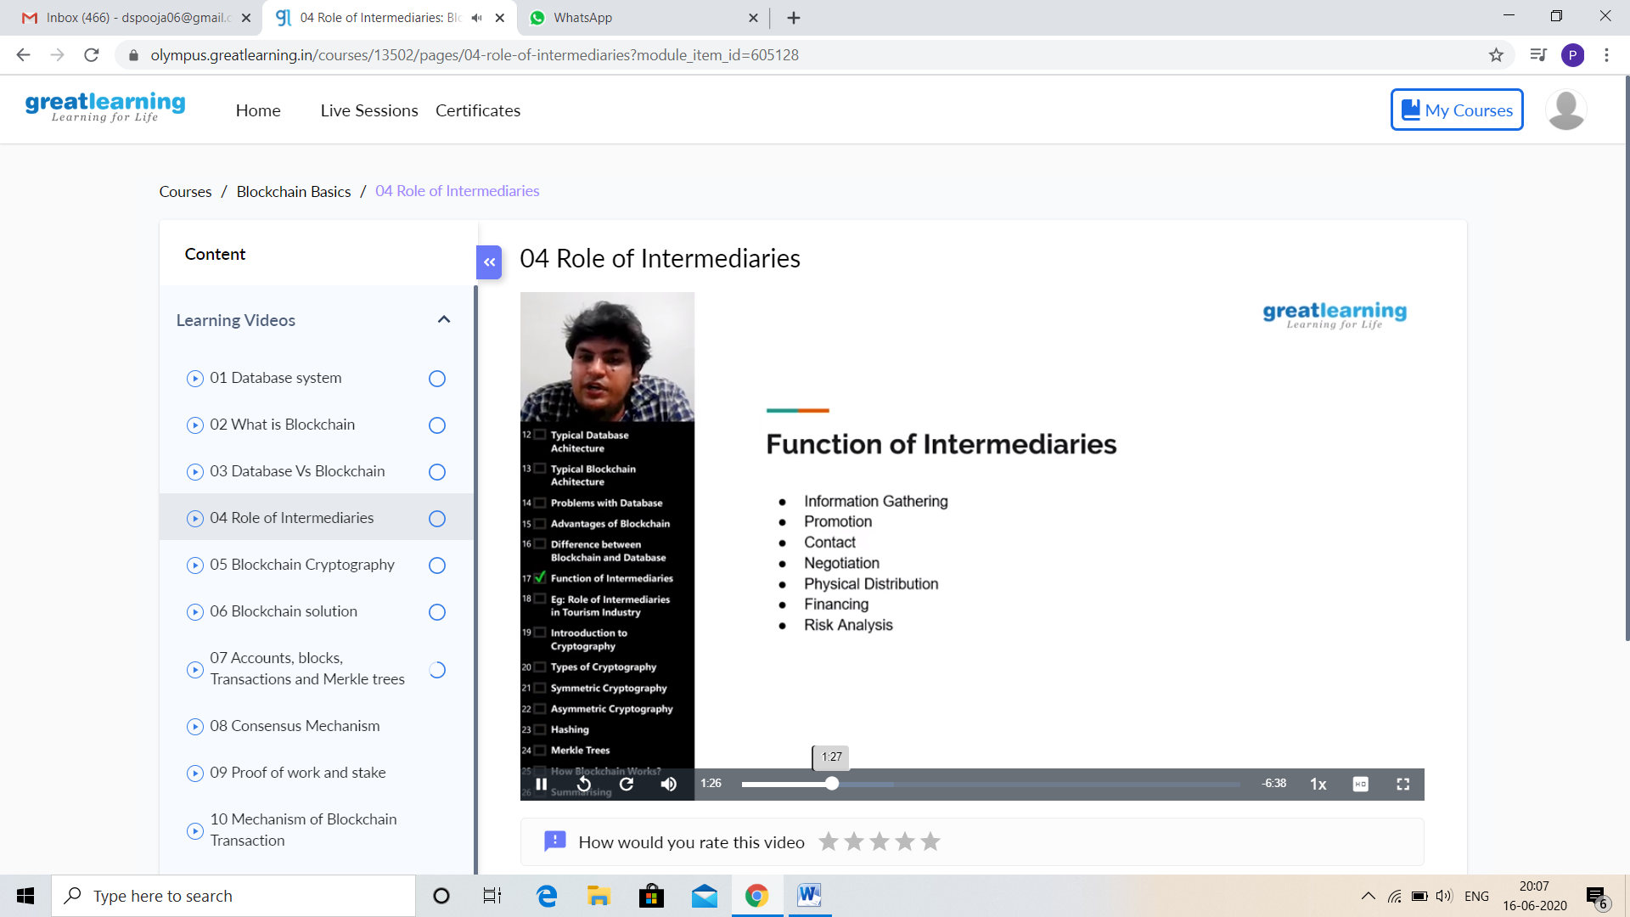

And I Participation in the Webinar “Application Design of Brain Computer Interface”. I got good Experience. And this is my certificate

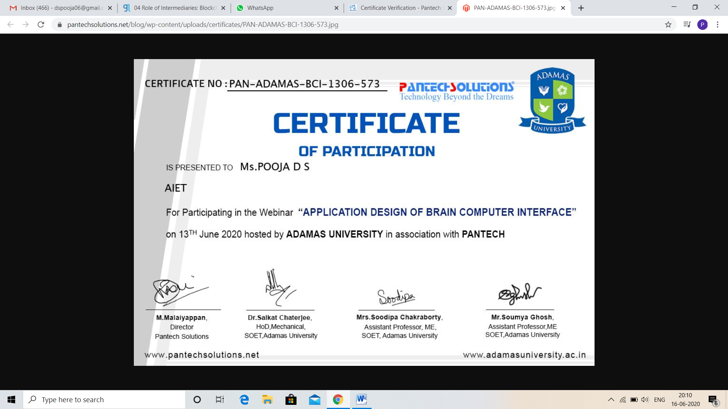

CODING CHALLENGES DETAILS:

Problem statement 1:

Write a Python program to check whether a given a binary tree is a valid binary search tree (BST) or not?

Solution: Uploaded in github.

